Container-based virtualization
Containers are a type of software that can virtually package and isolate applications for deployment. Containers can share access to an operating system (OS) kernel without the traditional need for virtual machines (VMs).
Container technology has roots in partitioning (1960s), and chroot process isolation (Unix, 1970s). Its modern form is expressed in application containerization, such as Docker, and system containerization, such as LXC (Linux Containers). Both of these container styles enable an IT team to abstract application code from the underlying infrastructure, simplifying version management and enabling portability across various deployment environments.
Container images include the information that executes at runtime on the OS, via a container engine. Containerized applications can be composed of several container images.
For example, a 3-tier application can be composed of front-end web server, application server and database containers, which each execute independently.
Containers are inherently stateless and do not retain session information, although they can be used for stateful applications. Multiple instances of a container image can run simultaneously, and new instances can replace failed ones without disruption to the application's operation.

How containers work
Containers hold the components necessary to run desired software. These components include files, environment variables, dependencies and libraries. The host OS constrains the container's access to physical resources, such as CPU, storage and memory, so a single container cannot consume all of a host's physical resources. Container image files are complete, static and executable versions of an application or service and differ from one technology to another.
Docker images are made up of multiple layers, which start with a base image that includes all of the dependencies needed to execute code in a container. Each image has a readable/writable layer on top of static unchanging layers. Because each container has its own specific container layer that customizes that specific container, underlying image layers can be saved and reused in multiple containers.

Containers vs. VMs
Containers are different from server virtualization in that a virtualized architecture emulates a hardware system. Each VM can run an OS in an independent environment and present to the application, via abstraction, a substitute to a physical machine. The hypervisor emulates hardware from pooled CPUs, memory, storage and network resources, which can be shared numerous times by multiple instances of VMs.
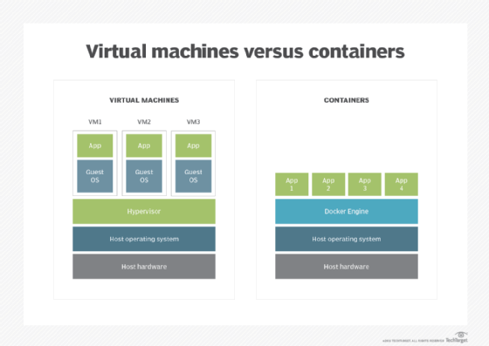

VMs take up more space because they need a guest OS to run. Containers don't consume as much space because each container shares the host's OS.
VMs can require substantial resource overhead, such as memory, disk and network input/output (I/O), because each VM runs an OS. This means VMs can be large and take longer to create than containers. Because containers share the OS kernel, only one instance of an OS can run many isolated containers. The OS supporting containers can also be smaller, with fewer features, than an OS for a VM or physical application installation.
Application containers, such as Docker, encapsulate the files, dependencies and libraries of an application to run on an OS. Application containers enable the user to create and run a separate container for multiple independent applications, or multiple services that constitute a single application.

Benefits of containers
Because containers share the same OS kernel as the host, containers can be more efficient than VMs, which require separate OS instances.
Containers have better portability than other application hosting technologies: They can move among any systems that share the host OS type, without requiring code changes. This encapsulation of the application operating code in the container means that there are no guest OS environment variables or library dependencies to manage.
Proponents of containerization point to gains in efficiency for memory, CPU and storage as key benefits of this approach compared with traditional virtualization. Because containers do not have the overhead required by VMs, such as separate OS instances, it is possible to support many more containers on the same infrastructure. An average physical host could support dozens of VMs or hundreds of containers —however, in actual operations, the host, container and VM sizes are highly variable and subject to the demands of a specific application or applications.
A major factor in the interest in containers is they are consistent throughout the application lifecycle. This fosters an agile environment and facilitates new approaches, such as continuous integration (CI) and continuous delivery (CD). They also spin up faster than VMs, which is important for distributed applications.

Disadvantages of containers
A potential drawback of containerization is lack of isolation from the host OS. Because containers share a host OS, security threats have easier access to the entire system when compared with hypervisor-based virtualization. One approach to addressing this security concern has been to create containers from within an OS running on a VM. This approach ensures that, if a security breach occurs at the container level, the attacker can only gain access to that VM's OS, not other VMs or the physical host.
Another disadvantage of containerization is the lack of OS flexibility. In typical deployments, each container must use the same OS as the base OS, whereas hypervisor instances have more flexibility.
Monitoring visibility can be another issue. With up to hundreds or more containers running on a server, it may be difficult to see what is happening in each container.

Container tool and platform providers
Docker and Kubernetes are well-known product names in the container technology space, and the technologies underpin many other products.
Docker is an open source application container platform designed for Linux and, more recently, Windows, Apple and mainframe OSes. Docker utilizes resource isolation features, such as cgroups and Linux kernels, to create isolated containers. Docker is an eponymous company formed to sell enterprise supported container hosting and management products. In November 2019 the company sold the Docker Enterprise business to Mirantis.

